0UTPUTS

**EXERCISE - 1**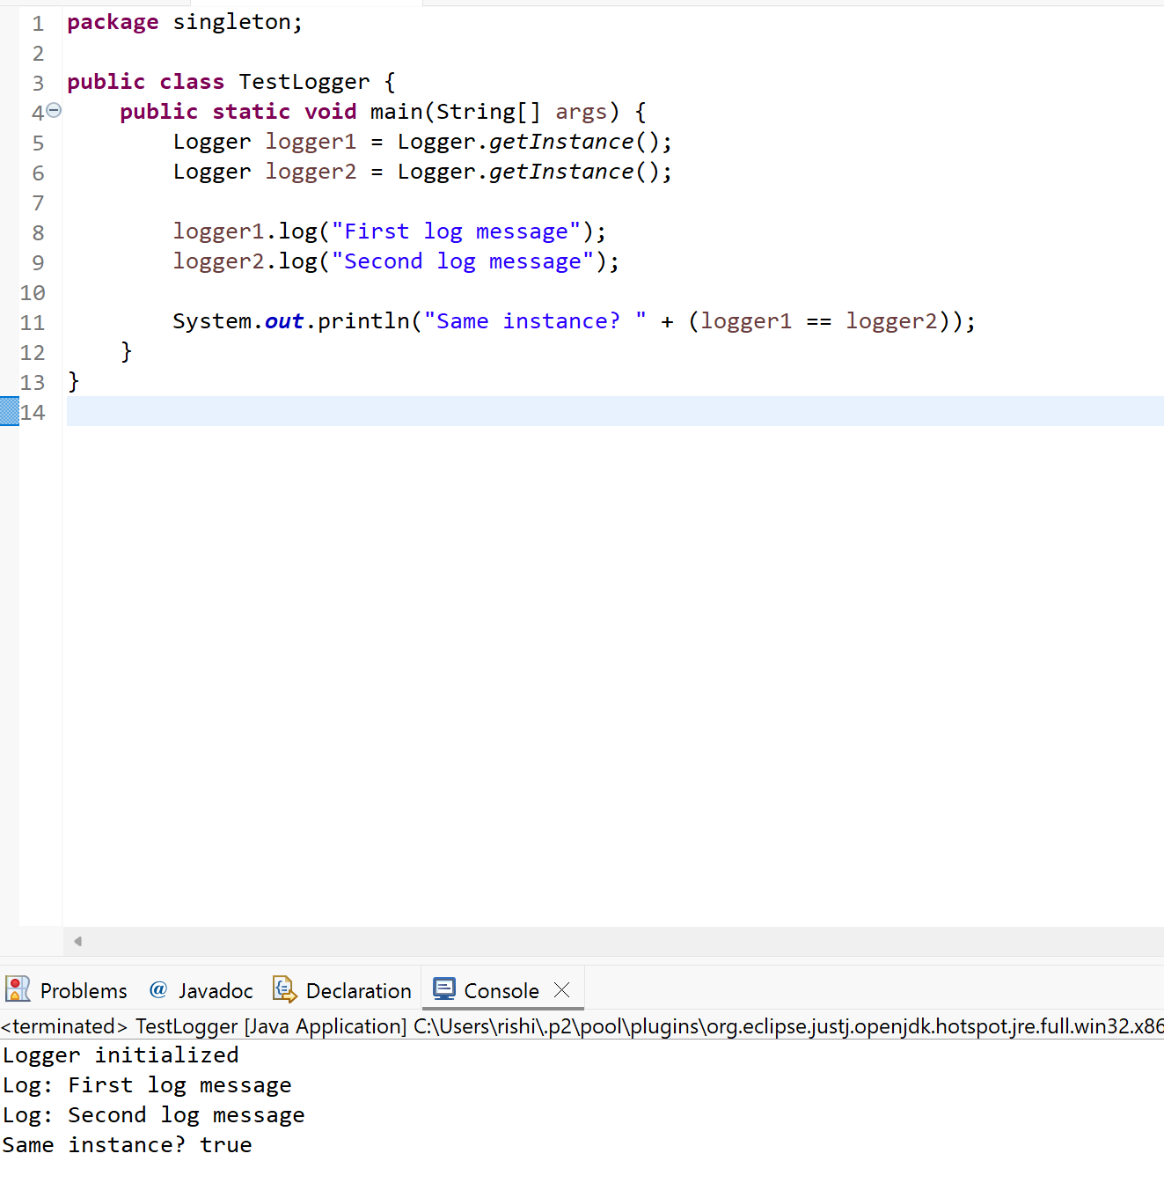

**EXERCISE – 2**

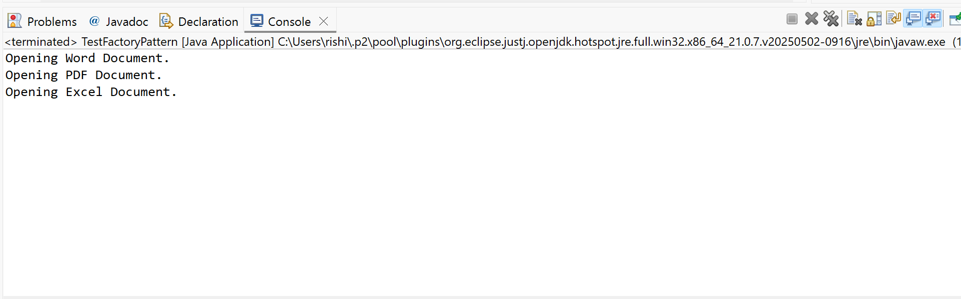

**EXERCISE – 3**

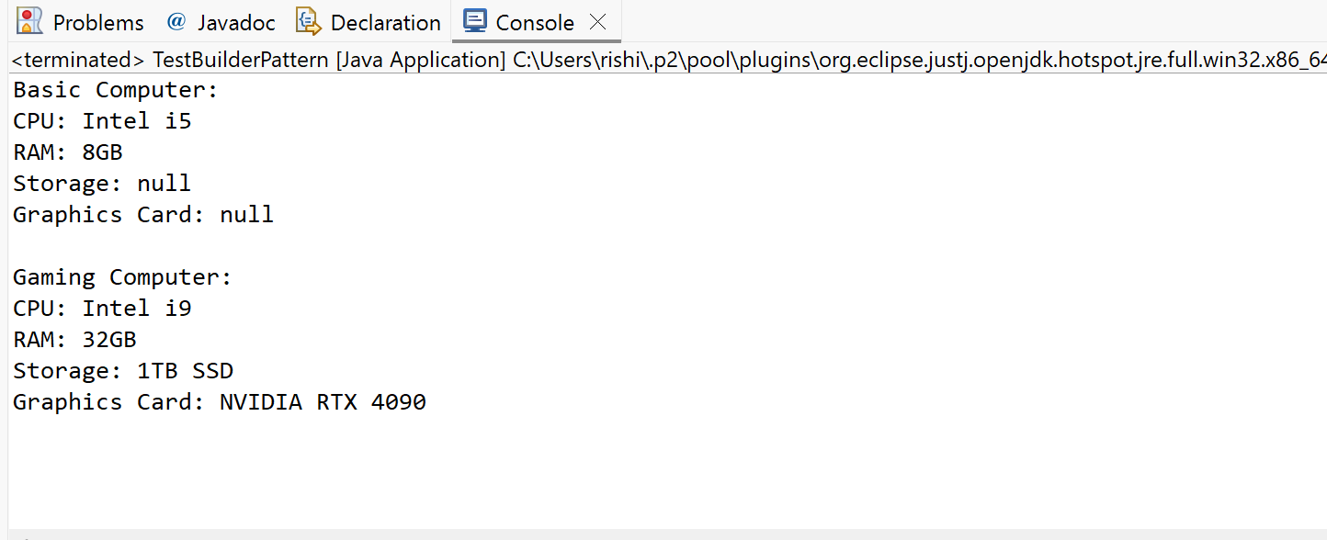

**EXERCISE – 4**

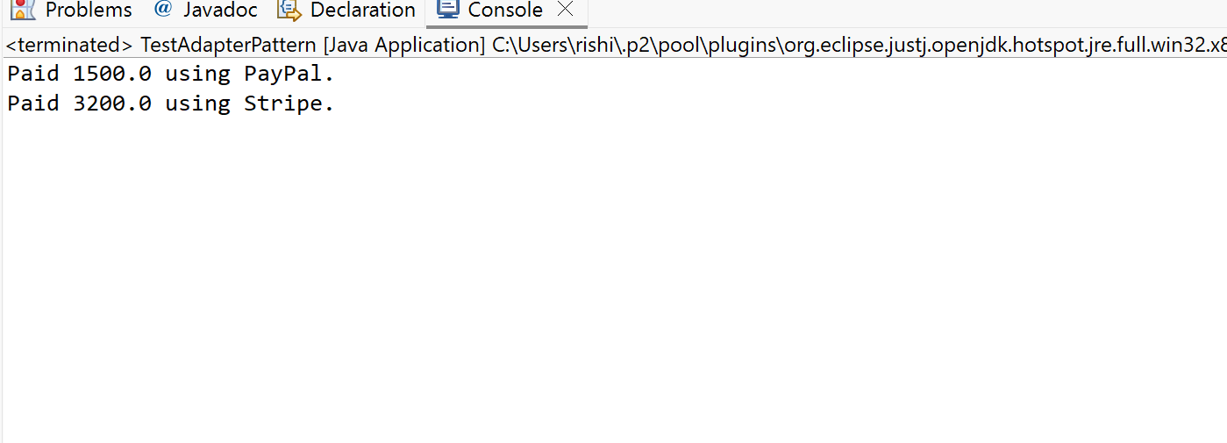

**EXERCISE – 5**

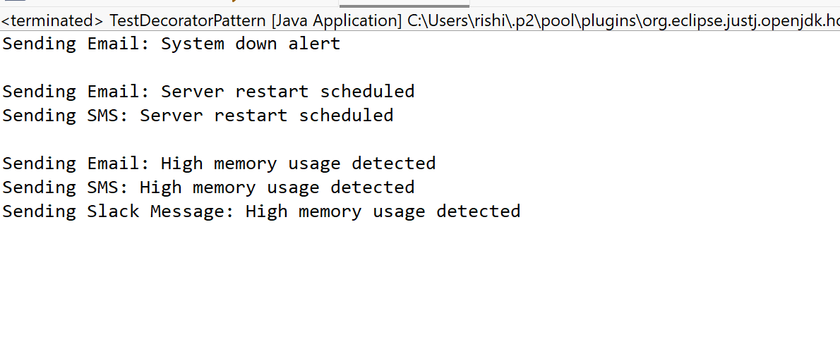

**EXERCISE – 6**

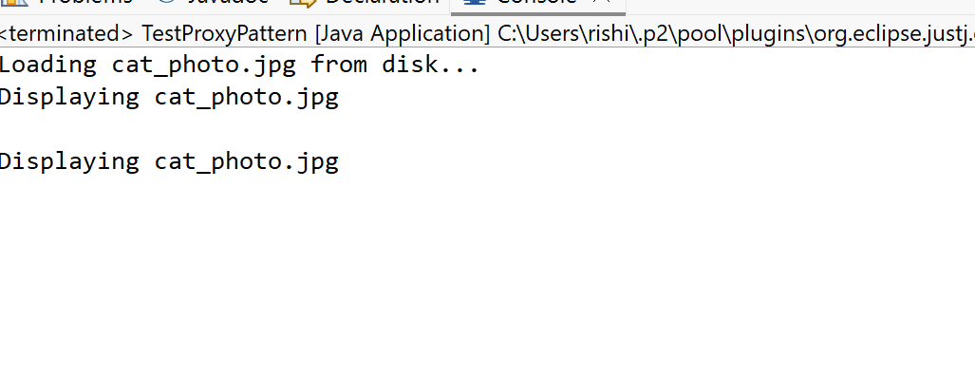

**EXERCISE – 7**

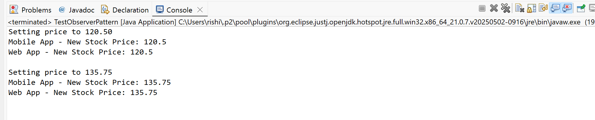

**EXERCISE – 8**

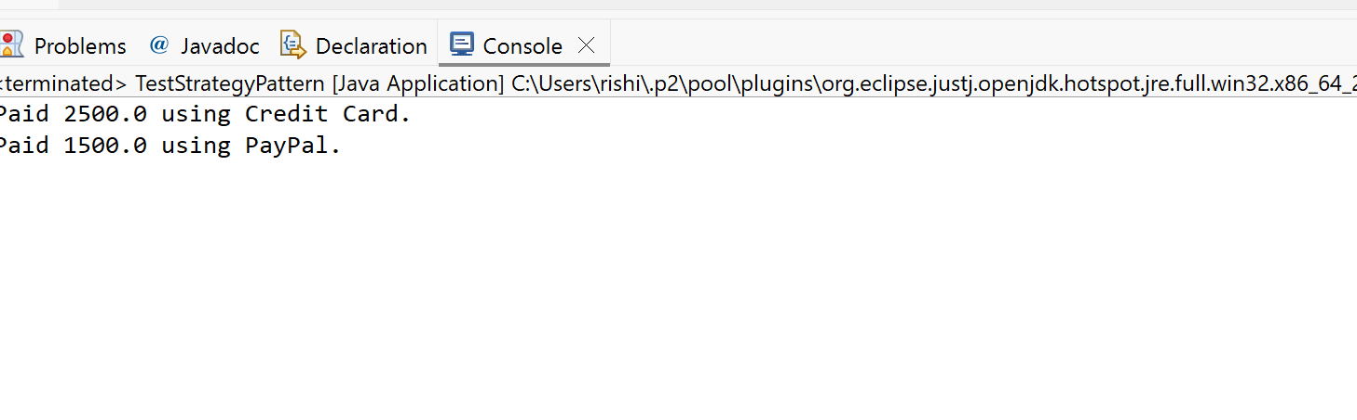

**EXERCISE – 9**

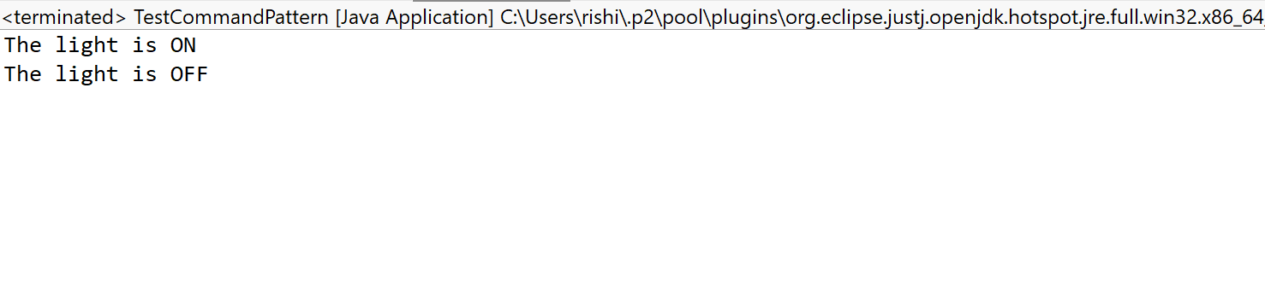

**EXERCISE – 10**

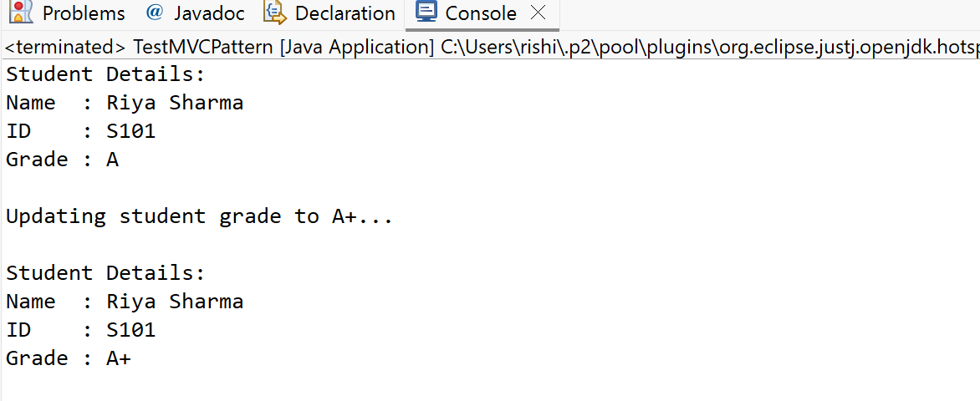

**EXERCISE – 11**

